1. **WoE (Weight of Evidence) vs. IV (Information Value)**

**WoE (Weight of Evidence)** and **IV (Information Value)** are two closely related concepts used in credit scoring, risk modeling, and data analytics to evaluate the predictive power of variables or features. They are typically used to assess the strength of the relationship between a categorical or continuous variable and the binary target variable (e.g., "good" or "bad" credit risk).

* **Weight of Evidence (WoE)** measures the **strength of the relationship** between a particular category or bin of a variable and the odds of the event occurring. It is calculated as the natural logarithm of the ratio of the proportion of events (e.g., good credit) to the proportion of non-events (e.g., bad credit) in that category.
* **Information Value (IV)** is a measure of the overall predictive power of a variable. It is calculated by summing up the WoE-based contributions for all categories of a variable. A high IV indicates a strong predictor, while a low IV suggests that the variable is less informative.

**Significance:**

In the context of WoE and IV, significance refers to the importance or strength of a variable in predicting the outcome of interest (e.g., credit risk). It helps identify which variables are the most influential in predicting the target variable. Variables with higher IV values are considered more significant in the modelling process.

**Case Studies/Use Cases:**

* **Credit Scoring**: WoE and IV are commonly used in credit scoring models to assess the importance of various factors (e.g., income, age, credit history) in predicting the likelihood of a borrower defaulting on a loan.
* **Marketing Analytics**: Marketers use WoE and IV to evaluate the effectiveness of different marketing channels, customer segments, or product features in driving desired customer actions (e.g., making a purchase).
* **Fraud Detection**: In fraud detection models, WoE and IV can help identify suspicious patterns or behaviors that indicate potential fraudulent activity.
* **Customer Churn Prediction**: In the telecommunications and subscription-based service industries, WoE and IV can be used to understand the significance of various customer attributes in predicting churn.
* **Healthcare Predictive Modeling**: WoE and IV can also be applied to healthcare data to assess the importance of various factors in predicting patient outcomes, such as disease risk or readmission rates.

**Example:**

Let's consider a **credit scoring** example. Suppose you are building a credit risk model, and one of the variables you're analyzing is "credit utilization ratio," which measures how much of a person's available credit they have used. You calculate WoE and IV for this variable:

You divide the data into categories (bins) based on the credit utilization ratio (e.g., <10%, 10-30%, 30-50%, >50%).

For each category, you calculate the proportion of good credit accounts (events) and bad credit accounts (non-events).

You compute the WoE by taking the **natural logarithm** of the ratio of event proportion to non-event proportion for each category.

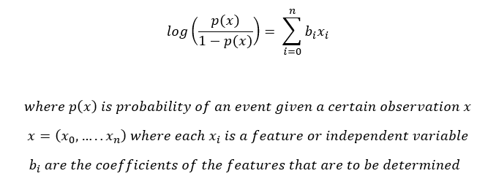

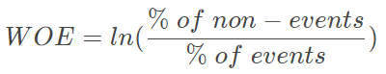Or,

Then, you calculate the IV by summing up the WoE-based contributions from all categories.

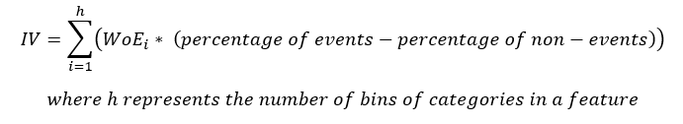

A high IV value for the credit utilization ratio would indicate that this variable is significant in predicting credit risk. A low IV value would suggest that it doesn't provide much predictive power. This information can help you make decisions about which variables to include in your credit scoring model.